
Blue the budgie
A Story by Lucan CNS Creative Week 2016
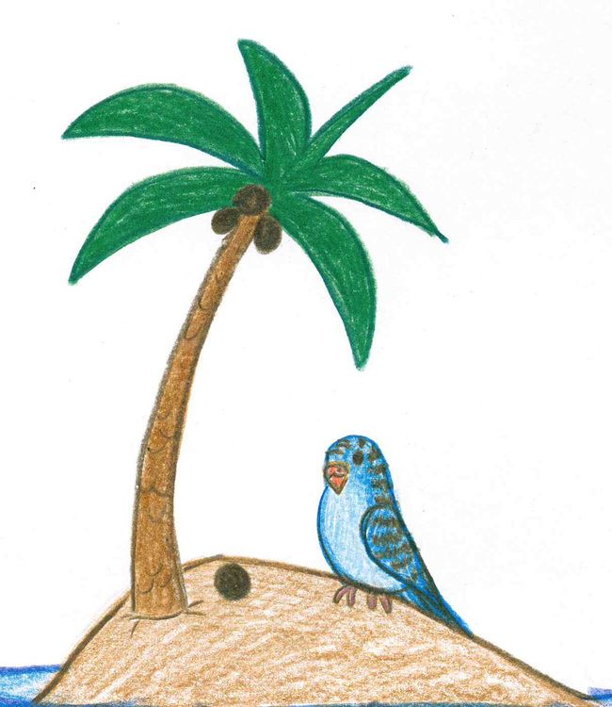
Typist:
Michelle Lattimore

Illustrator:
Victoria Burrows

Authors:
Jnr. Infants: Bianca, Chael, Ethan, Lily, Sophia
Snr Infants: Jan, Jathniel, Armandas, Claire, Leah, Mateusz, Rainne, Mia C.
1st Class: Kiki, Oliwia, Kai, Keeva
Blue the Budgie

Blue was a very kind and helpful budgie but sometimes he could be a little lazy. Blue lived in a big coconut tree on an island in Australia.

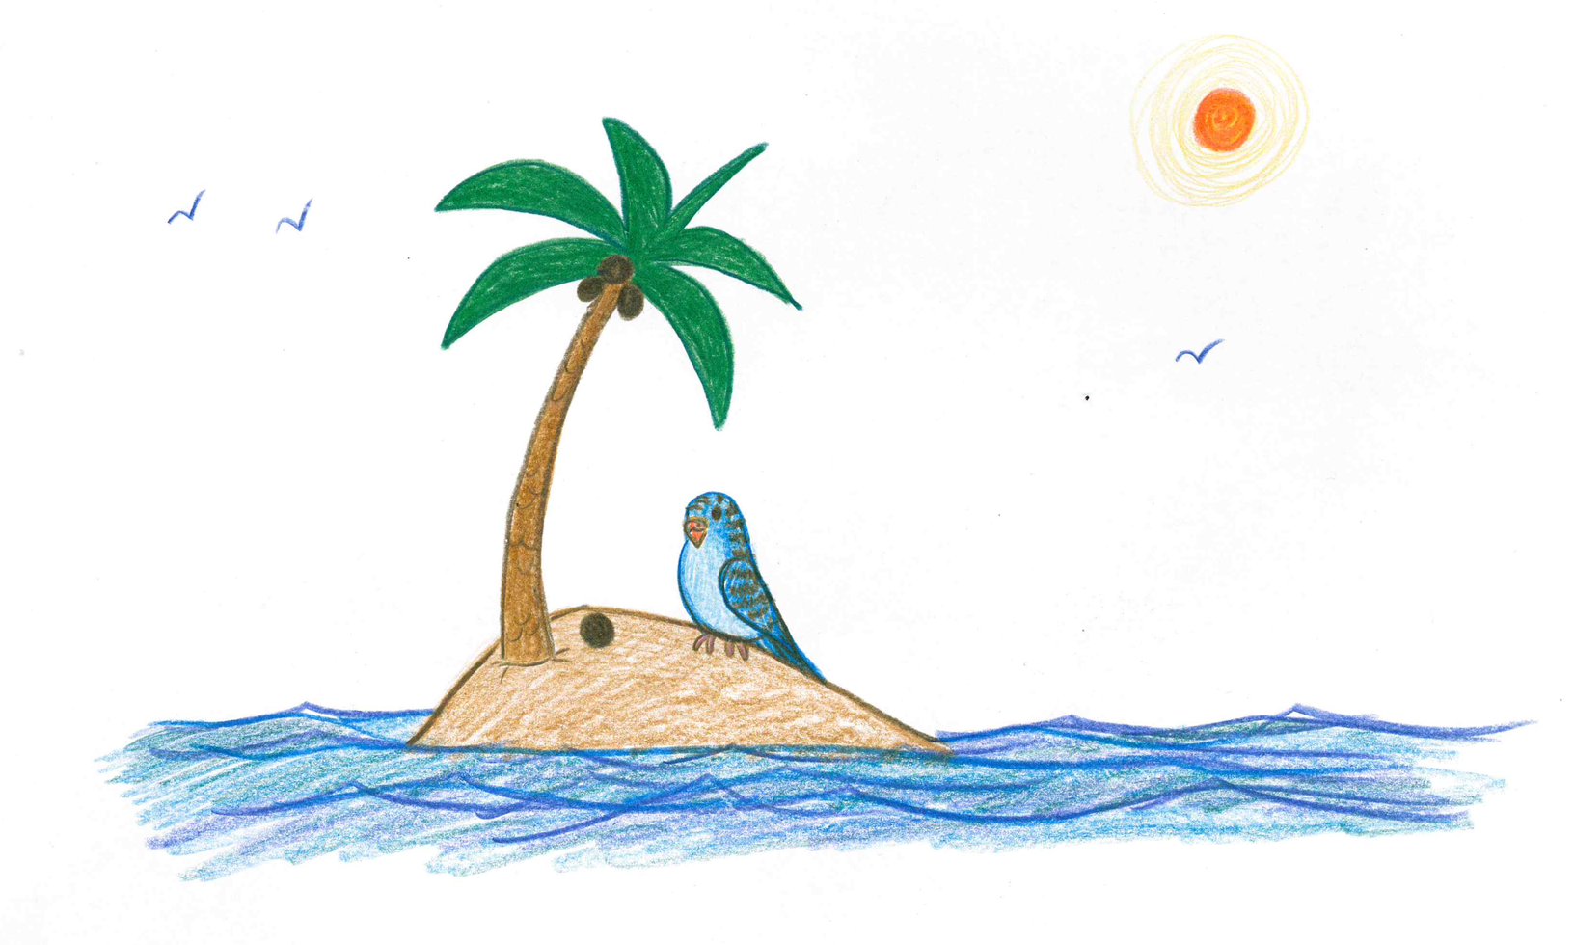

Blue the Budgie’s best friend in the whole wide world was Poco the Clever Robin.

Poco was a sweet robin but was very sleepy all the time! She was so sleepy because she spent most of her time answering other people’s questions - she was that clever!

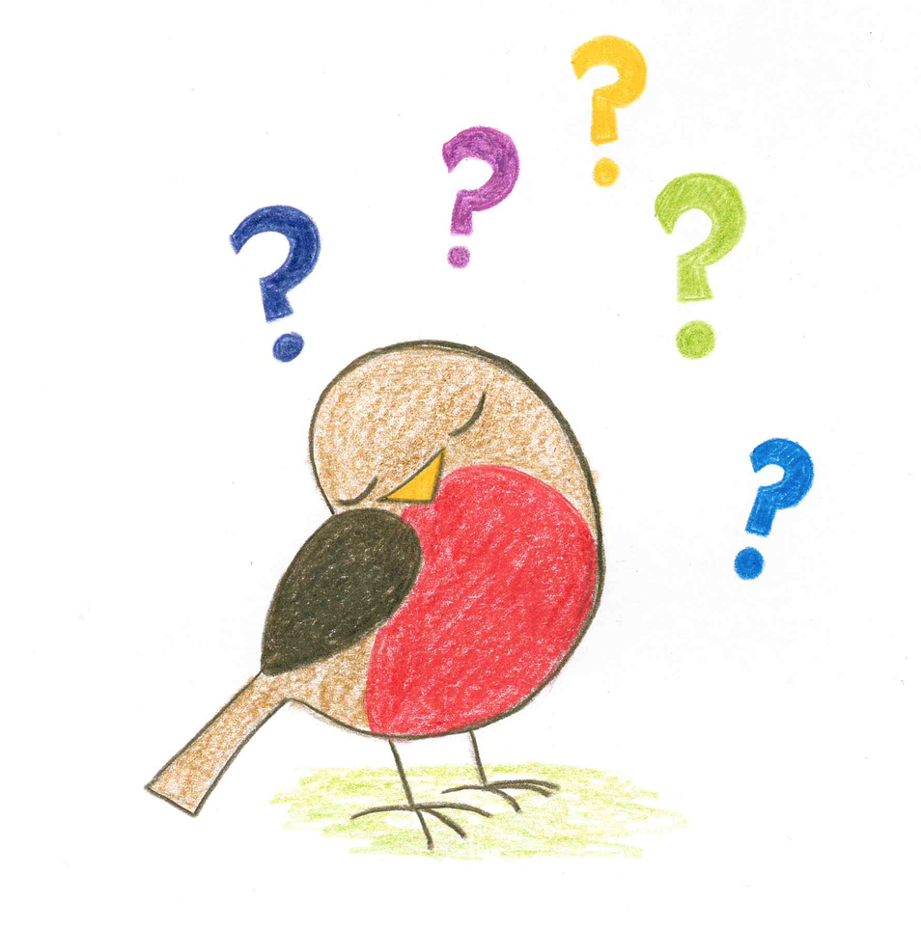
Blue the Budgie’s greatest wish was to have a baby brother.

Blue’s biggest fear was green-haired Spiders! These particular spiders had big teeth, great red eyes and hoarse voices ….. as though they always had a sore throat.
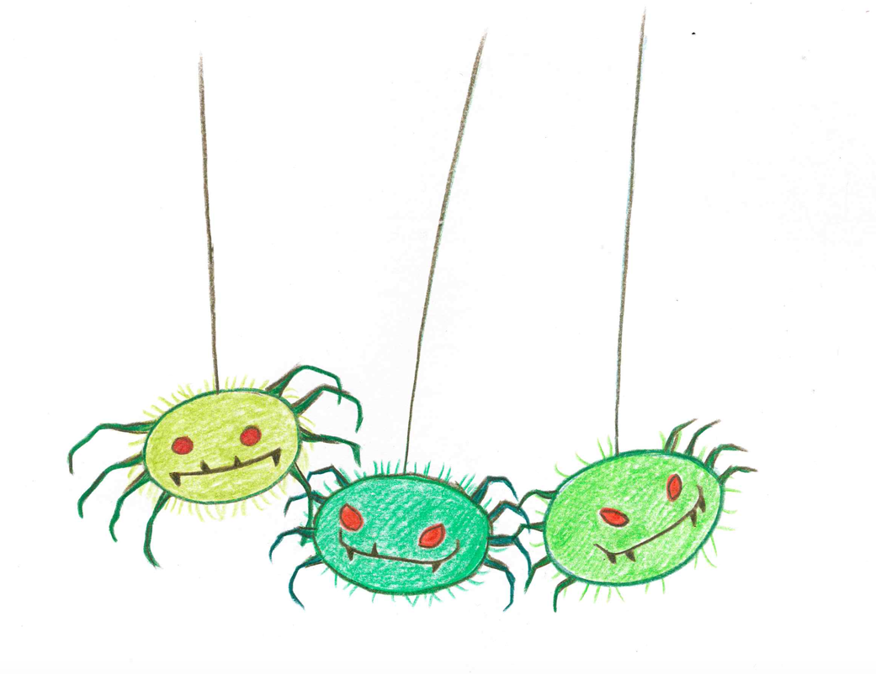
How was Blue the Budgie going to get a baby brother? He knew one person who had the answer to every question….. Poco the Clever Robin! Maybe she could tell him how to get a baby brother!

Poco said to Budgie (in her most wise voice), “Find an egg!”

Blue asked, “Where can I find such an egg?”

SNOOORE SNOOORE. Uh-oh, Poco had fallen asleep!

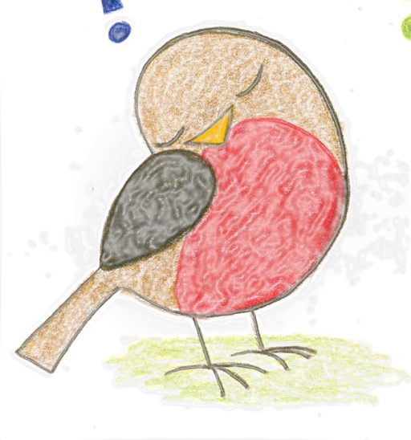

After a few minutes, Poco woke up with a snort.

She told Blue……….

What did Poco tell Blue?
Finish your story here!

