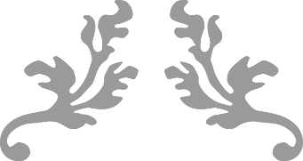
chompy, the great white shark
A Story by Lucan CNS Creative Week 2016
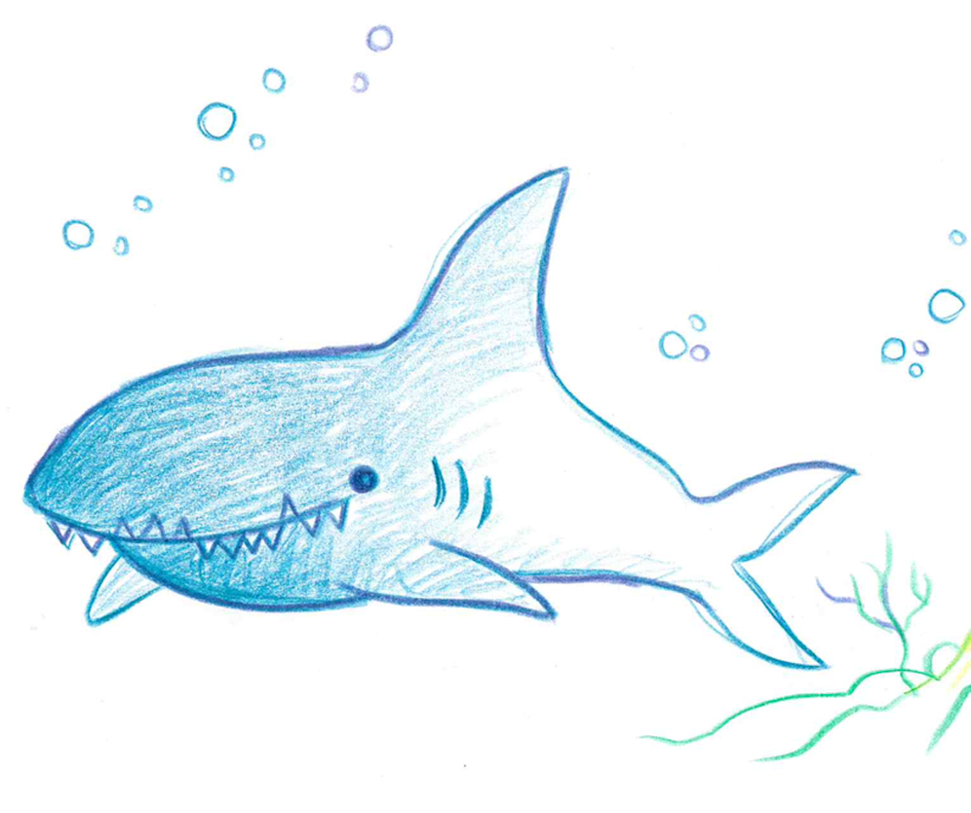
Illustrator:
Victoria Burrows

Typist:
Michelle Lattimore

Authors:
Jnr. Infants: Amalia, Garcia, Jaida, Naoise, Peace
Snr Infants: Brandon, Callum, Areeba, Simi, Suhani, Matthew, Wiktoria, Ava R.
1st Class: Ronan, Holly, Nick
Chompy, the Great White Shark

Chompy the Great White Shark lived in a cave under the sea, which was covered in a greenish-yellow dust. It smelled a little bit like rotten beans.

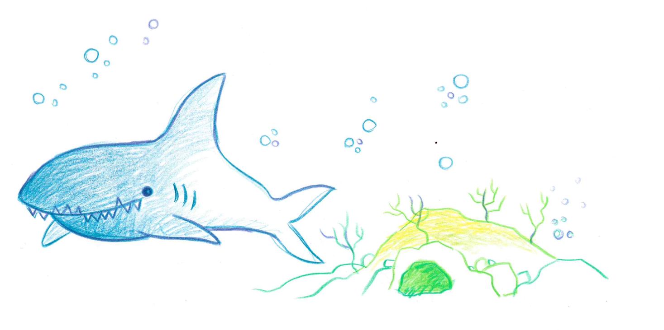

Chompy’s greatest wish was to find a nice, warm home in the Pacific Ocean.

His dream home would have a cooker, seaweed wallpaper, and he would live with his family, and his three friends (including his pal Finn, who was a Blue Whale).

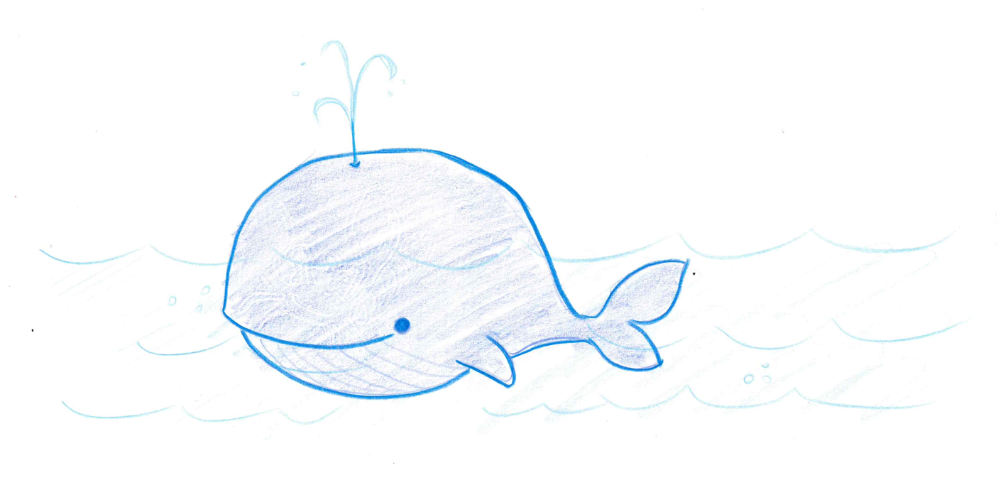
His best friend was Kai the Crab. Kai was a pinky white Hermit Crab and he was a bit clumsy, and sometimes when he would get very excited he would fall over. Chompy looked after his friend Kai.

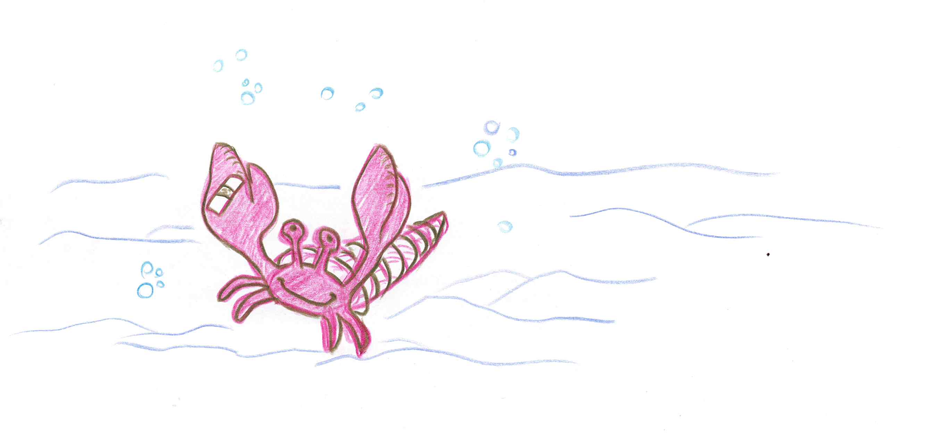
Chompy and Kai often went looking for food together. Chompy’s favourite food was pink marshmallows, not like any other sharks we know!

Chompy’s greatest fear was the Army of Gigantic Clams. These Clams had army tanks and slimy fish guns and they smelled horrid!!!!

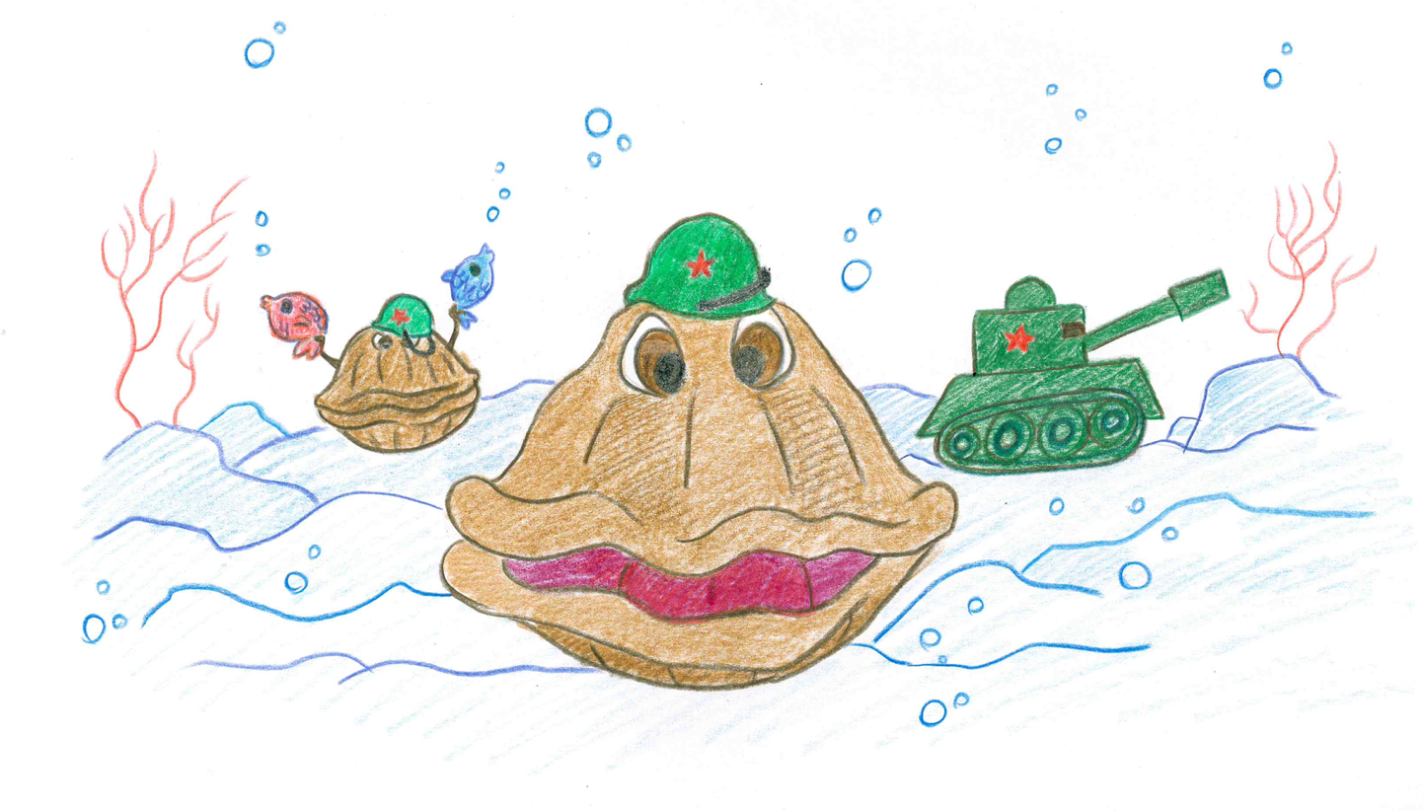
Chompy thought these Clams were mean and angry, but in fact the clams were just a little bit lonely. They didn’t have any other sea friends and their greatest wish was to be friends with Chompy, Finn and Kai.

Chompy wanted desperately to get to the Pacific Ocean but he didn’t know how. Maybe, he thought, with the help of his friends he might be able to get there……

What should Chompy do?
Finish your story here!

