
Snowy, the snow leopard
A Story by Lucan CNS Creative Week 2016

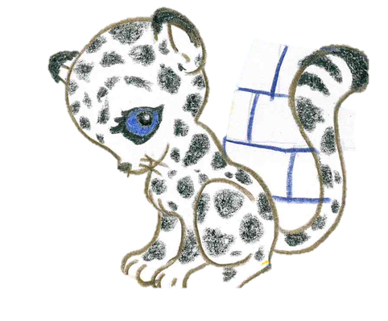
Illustrator:
Victoria Burrows

Typist:
Michelle Lattimore

Authors:
Jnr. Infants: Adrian, Alannah, Ava, Harshal, Maria
Snr Infants: Adriana, Aaron, Alicia, Jamie, Kayla, Ryan, Mia A., Michaela,
1st Class: Josh, Kris, Amelia, Jayden
Snowy, the Snow Leopard

This is a story about Snowy the Snow Leopard.

Snowy lived in an igloo in the middle of the desert.

Snowy’s best friend was a very clever boy named Smarty Preston, and he lived in the GPO.

Snowy’s greatest wish in the whole wide world was to finally taste ice cream.
He had never tasted ice cream before, but he had always wanted something delicious to cool him down.

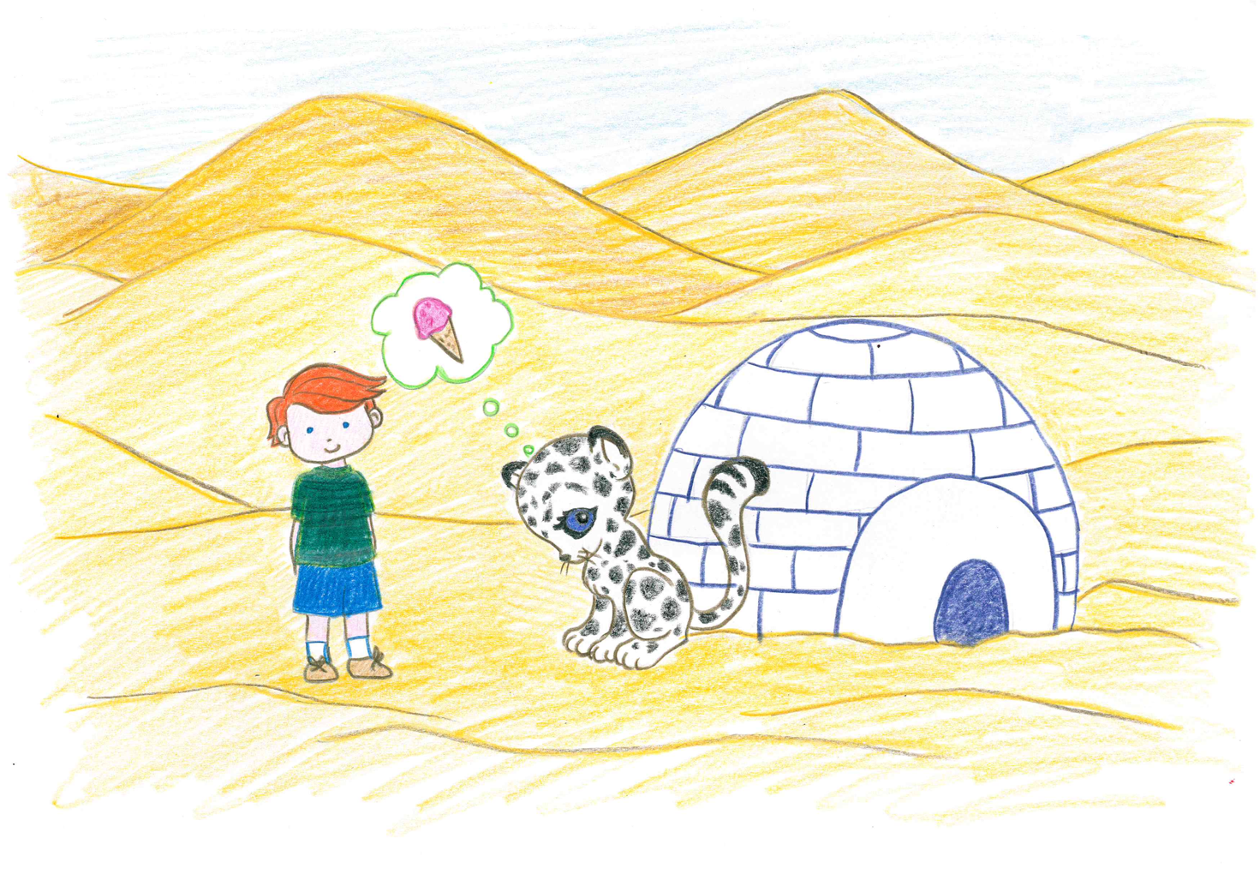

Snowy’s greatest fear was the dark. Snowy was afraid that when it got dark spiders, skeletons, talking statues, donkeys, talking bananas, zombies and all manner of scary things would come out.

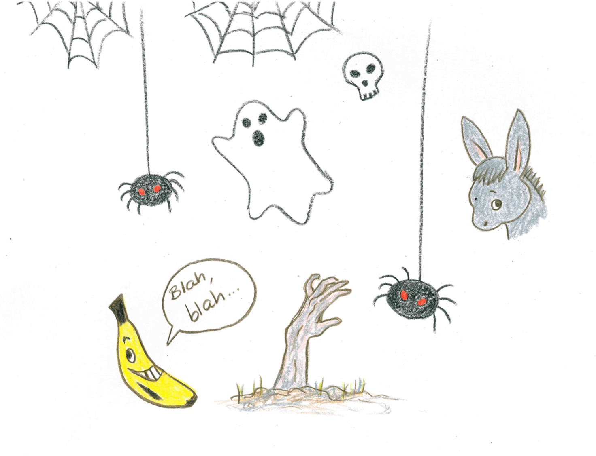

One day a Genie arrived in the desert. He was a very nice Genie, and he gave Snowy three wishes, but there was one catch. Snowy couldn’t wish for ice cream!

Snowy decided to cleverly wish for an ice cream van.

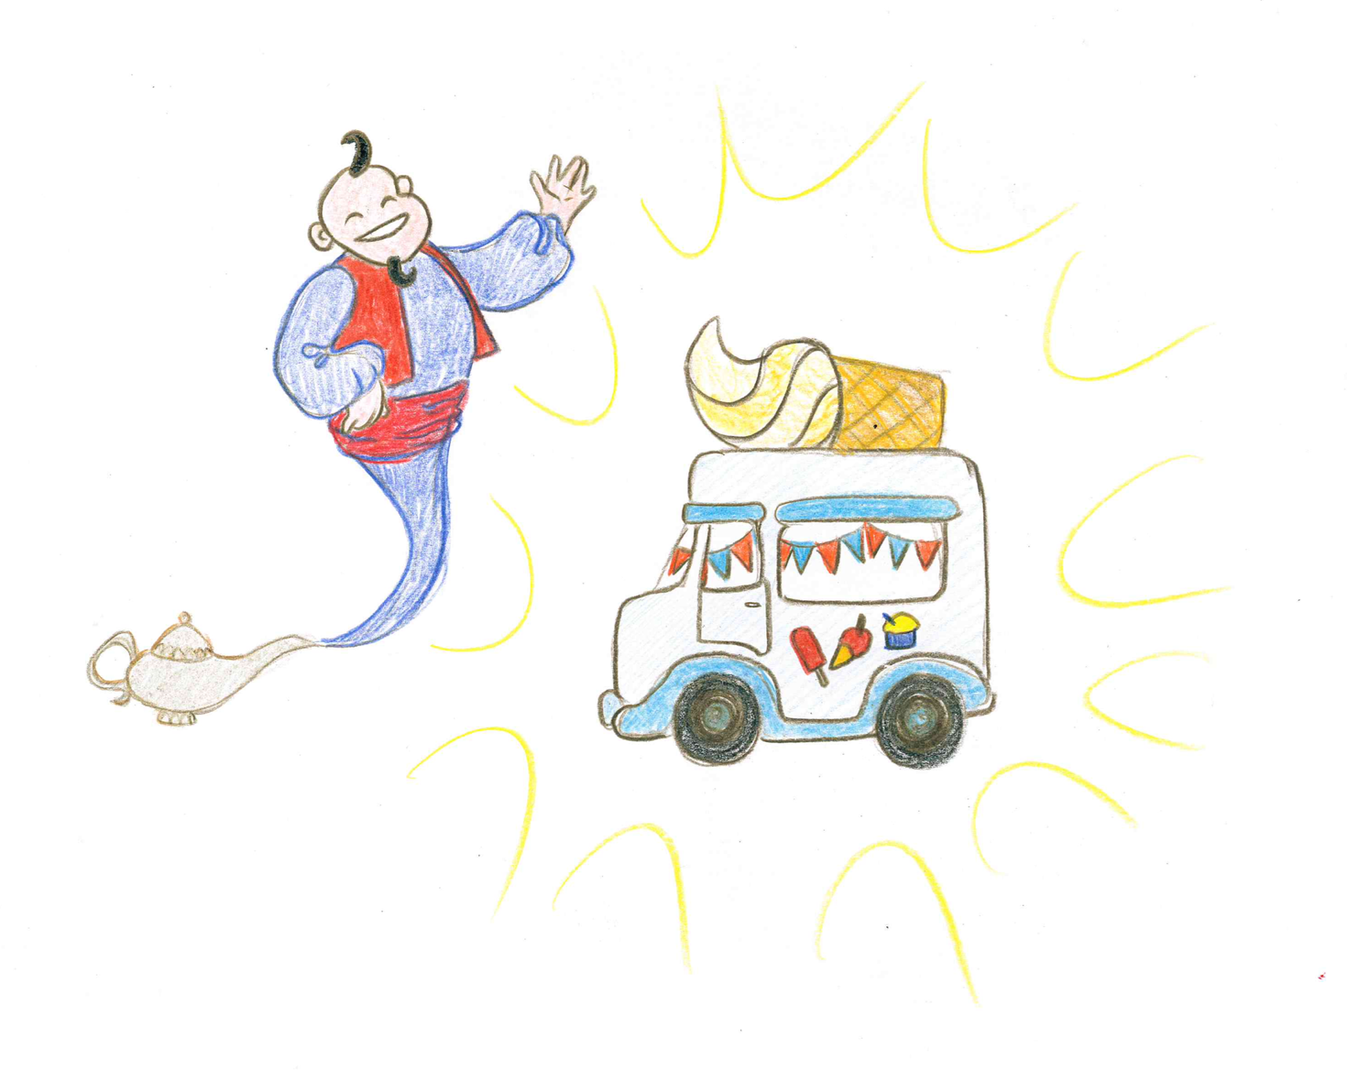
However, the ice cream van was very fast and poor Snowy couldn’t catch up to it.

And so, for Snowy’s second wish he asked for butterfly wings so he could fly after the ice cream van. He caught up to the ice cream van and said,
“Hey, Slowy! Can I have an ice cream?”

The ice cream man got such a fright (he had never seen a flying Snow Leopard before), that he dropped the ice cream on the floor!

The Genie told Snowy he only had one wish left so he had better choose carefully……….

What did Snowy wish for?
Finish your story here!

