
twinkles, the wild bunny
A Story by Lucan CNS Creative Week 2016
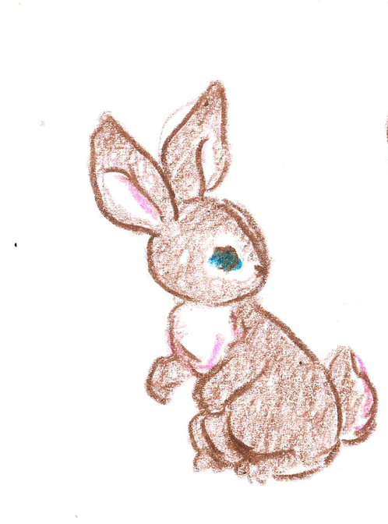
Typist:
Amanda O’Brien

Authors:
Jnr. Infants: Darragh, Denzel, Lauren, Vanessa
Snr Infants: Lorcan, Melania, Emma, Isabelle, Viktoria, Natalia, Myla, Agnes
1st Class: Zara, Róisín, Kernius, Kian, Alixia
Illustrator:
Victoria Burrows

Twinkles, the Wild Bunny

This is a story about a Wild Bunny called Twinkles. She was called Twinkles because her eyes twinkled a beautiful, cyan blue.

Twinkles was a ‘wild’ bunny because she jumped on all her animal friends (they didn’t like when she did that).
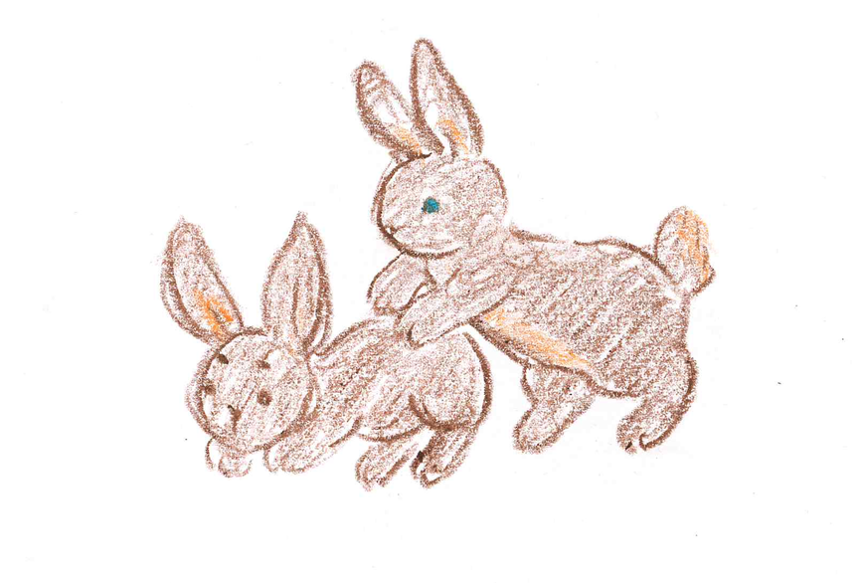
Twinkles lived in the Zoo, but her greatest wish was to be free in the forest. Twinkles had a best friend, an Evil Fairy called Kayleigh who lived high up in the trees in the forest. Twinkles thought Kayleigh was a Good Fairy, but when Twinkles wasn't looking, Kayleigh would do Evil Spells. Once, Kayleigh the Evil Fairy had even turned Twinkles’ mum Daisy into a mouse!

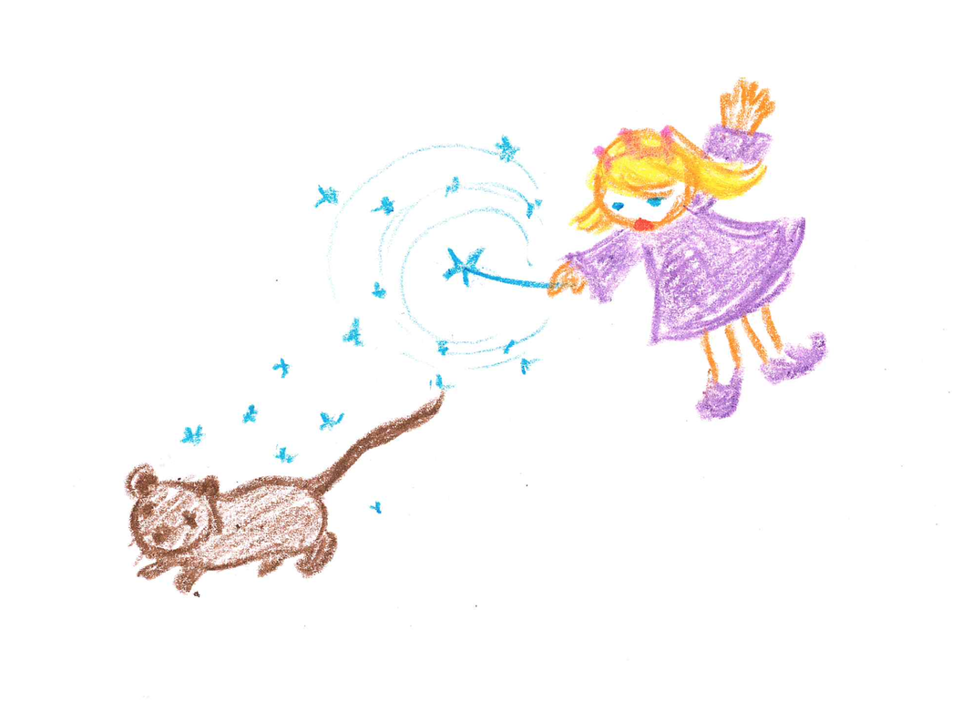
Twinkles greatest fear in the whole wide world was wolves. The wolves lived in a tunnel behind the trees in the forest. She often had nightmares that they chased her with their big, red fiery eyes and bit her.

One night Twinkles decided to break out of the Zoo, and run away to the forest. Nobody knew but Twinkles had a special super power that Kayleigh the Evil Fairy had given her! She had Super Claws (which were really, really sharp claws) and she used them to cut through a fence in the zoo.

However, just when Twinkles was about to escape, Kayleigh the Evil Fairy took her powers away! Twinkles was stuck in the middle of the fence - half way in and half way out…..!

Luckily, it just so happened that the boys and girls from Lucan CNS were on their school tour that very night when they came across Twinkles. They saw that she was stuck and yelping for help. Some of the children pulled her out and others broke the fence with a hammer. Twinkles escaped and shouted a big THANK YOU! as she ran off to the forest.

When Twinkles got to the forest it was snowing. She saw fiery eyes in the distance and she knew the wolves were on their way.
She started to run, and the wolves started to shout AROOOOWWWW. Suddenly Kayleigh the Evil Fairy appeared ………………..

What happens next to Twinkles?
Finish your story here!

